

**CSE2007 : Database Management Systems**

**Name :** Gudi Varaprasad

**Reg. No. :** 19BCE7048

School of Computer Science and Engineering

**Lab Slot :** L45 + L46

**Date :** 11 – 03 – 2021

**Submitted to :** Ms. Dhanavanthini madam

**Single row and Group Function Queries**

**Find the query and output for the given group functions :**

**Create the table employee and insert the listed values**

|  |  |  |  |  |  |  |
| --- | --- | --- | --- | --- | --- | --- |
| **NAME** | **DOB** | **DOJ** | **GENDER** | **SKILL 1** | **SKILL 2** | **SALARY** |
| ANITHA | 30-JUN-60 | 28-APR-75 | F | C++ | ASP.NET | 1000 |
| KAMALA | 28-APR-75 | 20-MAY-92 | F | DBASE | C#.NET | 2000 |
| MARY | 30-MAR-91 | 09-APR-05 | F | C++ | DBASE | 2020 |
| ANAND | 02-JAN-89 | 20-APR-09 | M | ORACLE | C | 2100 |
| KARTHICK | 11-FEB-70 | 15-JUN-12 | M | JAVA | C++ | 2500 |
| VIJAY | 29-OCT-82 | 15-JUN-12 | M | C#.NET | C++ | 2520 |
| JAGADESH | 19-DEC-87 | 15-JUN-12 | M | COBOL | C++ | 2500 |

**Output :**

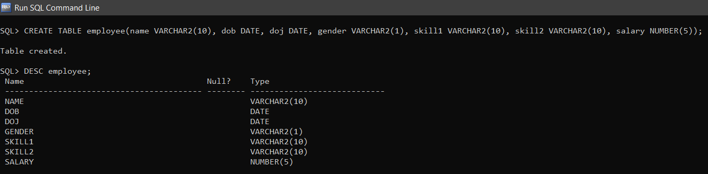

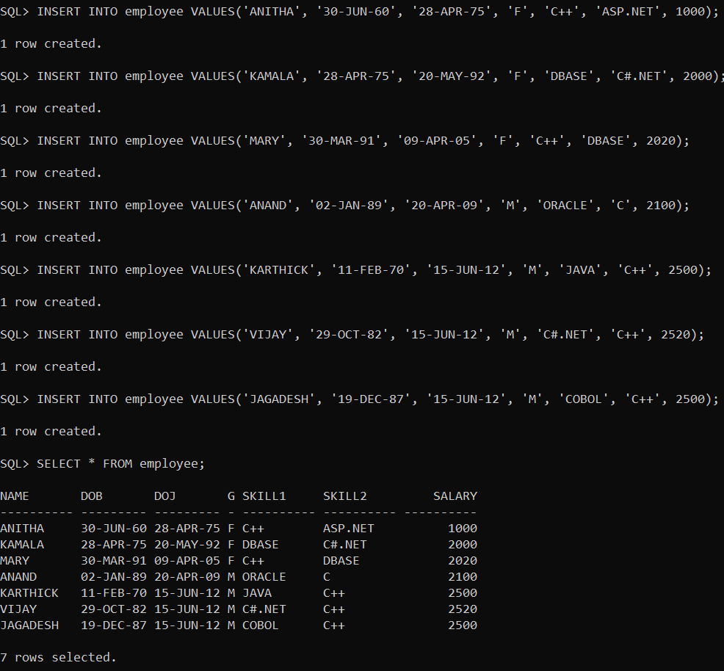

**1. How many female programmers are there?**

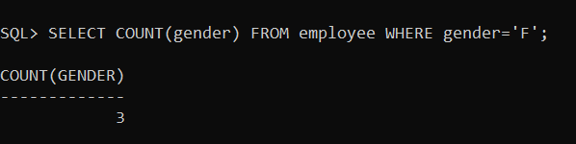

**2. What is the Average salary?**

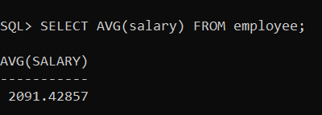

**3. How many programmers know either Cobol or Pascal?**

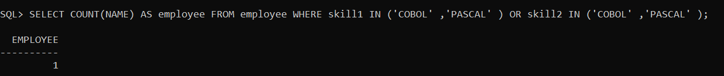

**4. What is the average age of female programmers?**

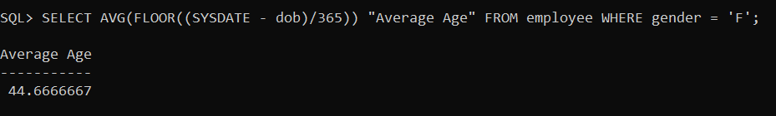

**ALTERING TABLE to add column PACKAGES**

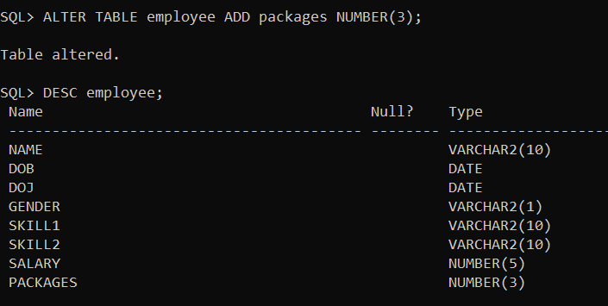

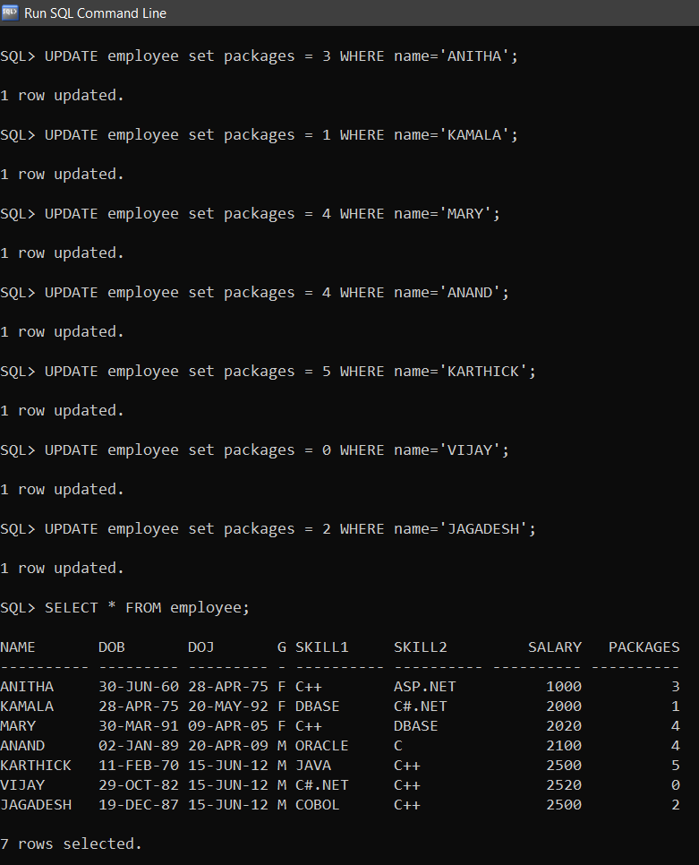

**5. Display the NUMBER of packages developed by EACH programmer.**

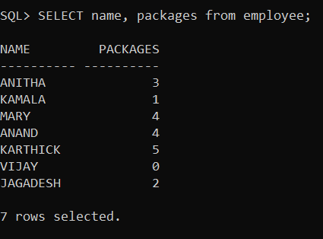

**6. Display THE NUMBER OF male and female programmer.**

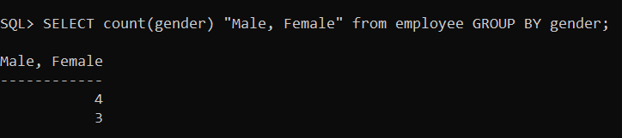

**7. Display the programmer's name and their packages.**



**8.How many employees were paid 5000 to 10000?**

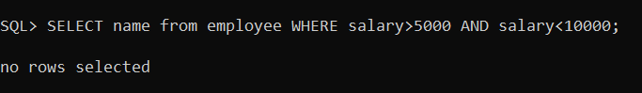

**9.Give the average salary paid for the employee who have the C++ skill.**

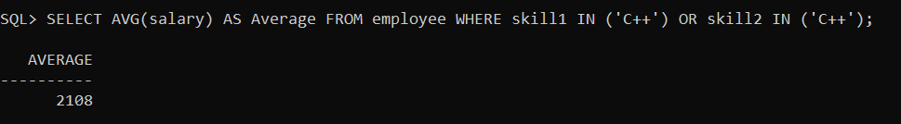

**10. Which employee paid the highest salary with their skills name ?**

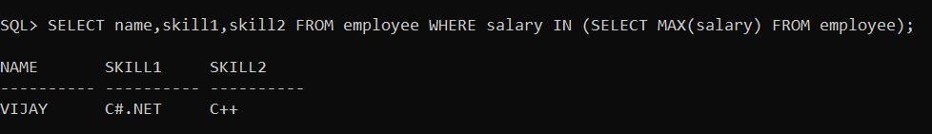

**11. Which employee paid the lowest salary?**

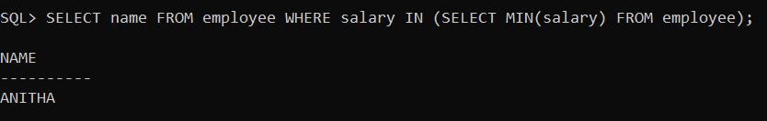

**12. Give the total salary paid for the skill C#.net**



